**University Transport Management System**



**By**

**Zain Abbas(team lead)**

**Talha Bilal**

**Shaheer Hamza**

**Sabina Jaffar**

**Department of computer science**

**Quaid-e-Azam University Islamabad**

**Signature Page**

Zain Abbas ,Talha Bilal, Shaheer Hamza ,Sabina Jaffar at Quaid-e-Azam University created the original document named "University Transport Management System" throughout their academic period. The project proceeds with strict compliance to IEEE guidelines to establish secure coding standards. The document includes all data and content which has received proper citations and source attributions throughout the document. This document originates from the academic period at Quaid-e-Azam University but has never been submitted to any other academic event or public award competition. The document serves as proof of our dedicated work without dependency that brings together our computer science knowledge with personal dedication in the field.

**Date: 05/04/2025**

**Signature of Instructor:**

**___________________**

**Change History:**

|  |  |  |  |
| --- | --- | --- | --- |
| **Version** | **Date** | **Author** | **Summary of Changes** |
| Version 1.0 | 05/4/2025 | Zain Abbas  Talha Bilal  Shaheer Hamza(team lead)  Sabina Jaffar | Initial draft submission |
|  |  |  |  |
|  |  |  |  |

**Preface**

The University Transport Management System project management plan appears in this document. The document establishes project boundaries along with objectives and implementation approach that follows ISO/IEC/IEEE 16326 standards. The document presents the University Transport Management System project plan which contains project context alongside planning and risk management and supporting process plans.

**Table of Contents**

**List of figures ……………………………………………………………………………………. 5**

**List of tables …………..…………………………………………………...………………...........5**

**1. Project overview………………………………………………………………………………..7**

* **Project summary……………………………………………………7**
* **Purpose……………………………………………………7**
* **scope ……………………………………………………7**
* **objectives ……………………………………………………7**
* **Assumptions……………………………………………………8**
* **constraints ……………………………………………………8**
* **Project deliverables ……………………………………………………8**
* **Schedule summary ……………………………………………………8**

**2. References ……………………………………………………………………….......................9**

**3. Definitions …………………………………………………………………………………..…10**

* **Process model ……………………………………………………10**
* **Methods……………………………………………………….....10**
* **Tools ………………………………………………………............10**
* **Techniques ………………………………………………………...10**

**5. Project planning.………………….………………………………………………………11**

**8. Supporting process plans ………………………………………………………….13**

* **Risk management ……………………………….…………………13**

**9. Use case diagram .………………….…………………………………………………….14**

**10. Use case description.………………….…………………………………………………….15**

**11. System Sequence diagram………….……………………………………………………….18**

**12. Domain Model.………………….………………………………………..………………….15**

**13. Data dictionary.………………….………………………………………..………………….15**

**List of Figures**

1. Figure 1 - 3: Gantt Charts – Page # 10-11
2. Figure 4: Resource Allocation – Page #11
3. Figure 5:Use case diagram – Page #13
4. Figure 6:Use case diagram – Page #18
5. Figure 7:Use case diagram – Page #19
6. Figure 8:Use case diagram – Page #29
7. Figure 9:Use case diagram – Page #
8. Figure 10Use case diagram – Page #

**List of Tables**

1. Table 1: Risk Management Table – Page #12

**Project Overview(Sabina Jaffar)**

**Summary:**

The University Transport Management System functions to simplify transportation operations in the educational site. The system provides services to keep track of all transport options while the system helps students determine which buses serve their intended routes. Through its features the system facilitates transport requests by departments by managing pick-up or drop-time specifications alongside chosen locations. The system keeps comprehensive records about vehicle service which guarantees operational effectiveness.

**Purpose:**

The creation of an efficient automated transport management system aims to improve accessibility through scheduling and requisition features for students and faculty members as well as administrative personnel.

**Scope:**

The system operates with user registration and regulation of bus schedules along with request tracking and maintenance tracking services in addition to administrative functionalities.

**Objectives:**

The objective of system is to

* Create a centralize system to manage university transport
* Maintain vehicle maintenance records.
* Create an interface which is accessible to both university staff members and students.
* Departments should be able to request transport service when their pick-up or drop-off areas have predetermined locations.

**Assumptions:**

* Through mobile or web applications students together with faculty members access the platform.
* The university has allocated funds to sustain the system operation.

**Constraints:**

* Budget limitations for advanced features.
* The current university databases possess integration difficulties that impede integration.

**Project Deliverables:**

* A web-based and mobile application constitutes our functional transport management platform.
* The database stores information about vehicles as well as schedules and keeps maintenance records.
* The department can access the transport requisition module through this system
* User manuals and documentation
* System testing and validation reports

**Schedule summary:**

|  |  |  |
| --- | --- | --- |
| **Phase** |  | **Weeks** |
| 1 | Requirements gathering | 2 |
| 2 | System design | 3 |
| 3 | Development | 5 |
| 4 | Testing and validation | 3 |
| 5 | Development and training | 2 |

**(Talha Bilal)**

**References:**

1. ISO/IEC/IEEE 16326 for Project Management Guideline.
2. University Transportation Guidelines and Policies

**Definitions:**

* **Admin:**T he University administration team conducts transport operation supervision while scheduling vehicles and processing transportation requests while tracking equipment documentation.
* **User**: Students and academic faculty members together with university staff compose the group of users who commute with university transport services.
* **Transport Requisition**: A university department or their designated personnel submits formal requests for additional transport services through the Transport Requisition system which indicates all required pickup sites, drop locations and service specifications.

**Project context(Zain abbas )**

**Process Model:**

We will choose **Agile Process Model** for the development of university transport Management System. It is because

1. It allows for the incremental development, enabling us to deliver usable portions of the system in short cycles, ensuring feedback and adaptability to changing requirements.
2. It promotes a collaborative approach among team members and stakeholders.
3. Its iterative nature incorporates improvements.

**Tools:**

|  |  |
| --- | --- |
| Microsoft Word | For documentations |
| Project Libre | For Project Management and Scheduling |
| Visual Studio | For Code editing |
| Visual Studio Code | For Code editing |

**Methods:**

1. Requirements Analysis
2. Design
3. Coding and Development
4. Testing
5. Documentation

**Techniques:**

1. Requirements gathering techniques.
2. UML
3. Testing Techniques
4. Quality Assurance Techniques

**Project Planning:(Shaheer hamza )**

**Fig-1**

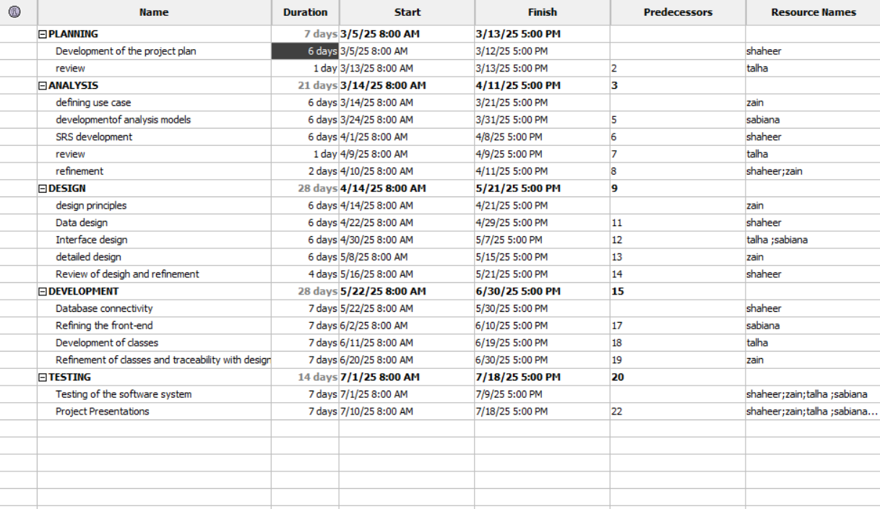

**Fig-2**

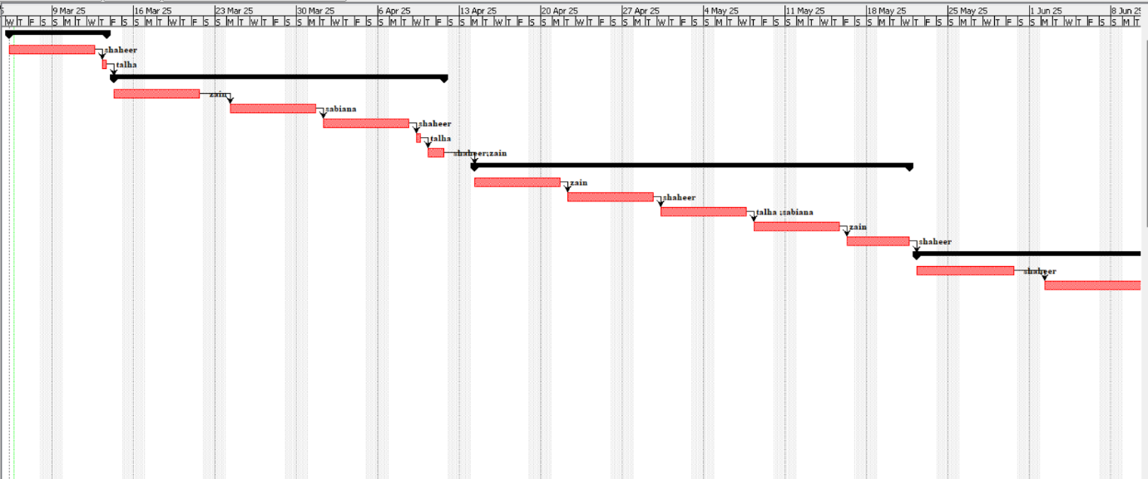

**Fig-3**

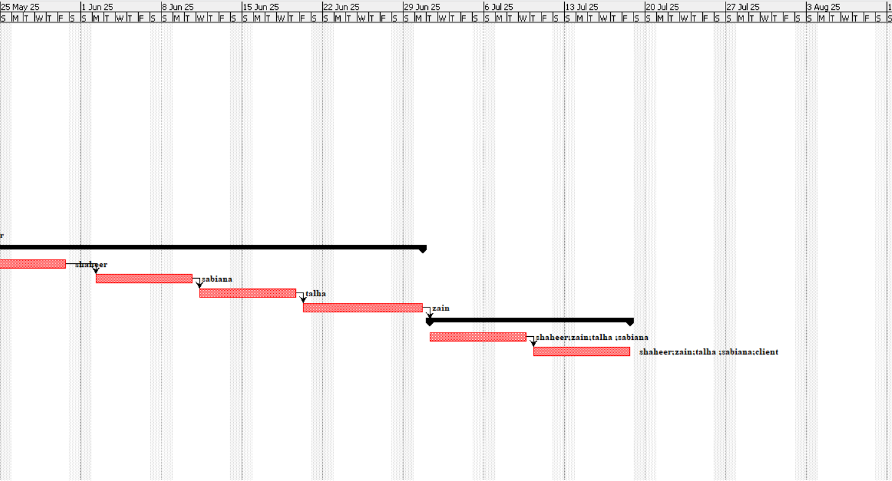

**Fig-4**

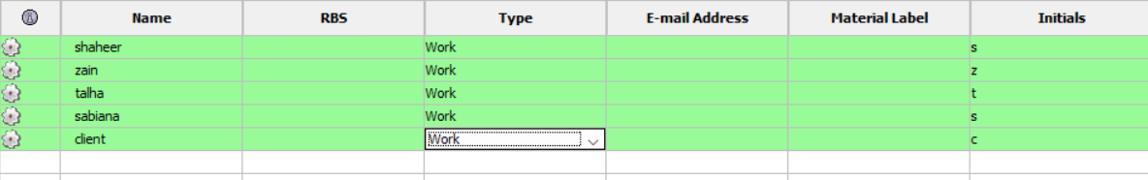

**Risk Management:(Talha Bilal)**

|  |  |  |  |
| --- | --- | --- | --- |
| **Risk** | **Probability** | **Impact** | **Mitigation Strategy** |
| System downtime | Medium | High | Implement redundancy and backups |
| Security breaches | High | High | Use encryption and access control |
| Budget overrun | Medium | Medium | Regular monitoring and cost control |
| User Resistance | Low | Medium | Conduct training and awareness sessions |

**Use case diagram**

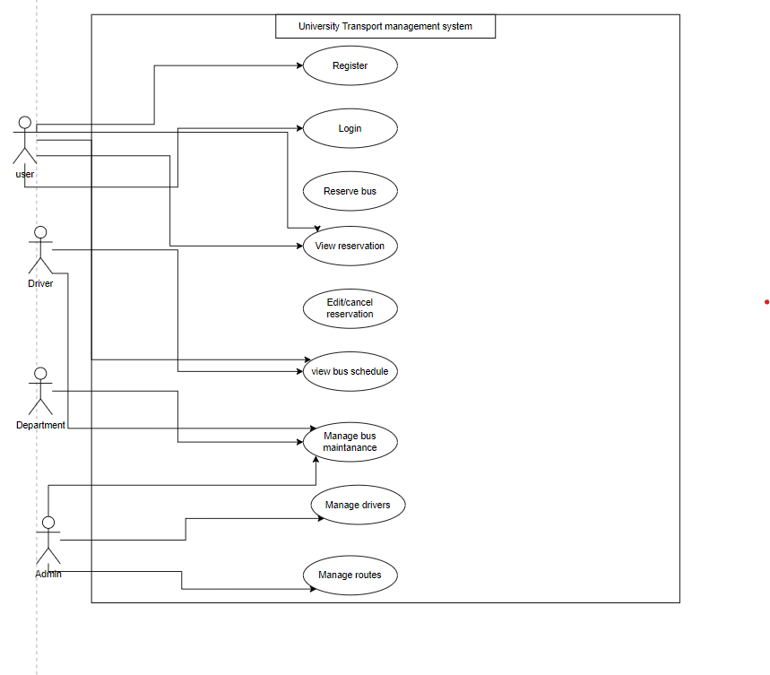

**Fig-5**

**Use case description**

**Shaheer hamza**

**Use Case Title**: login

**Primary Actors:** User (Student, Faculty, Driver)

**Precondition:**

* All users need a pre-existing account within the system.
* The operational status of the system needs to be intact.

**Post condition:**

* After verifying login success the system grants system access to users.
* The user needs to revoke their password after login failure.

**Basic Flow:**

1. The user starts the login process by accessing the appropriate screen.
2. The user must provide their registration number together with their name and password.
3. The system performs a verification process for the entered information.
4. The system will display "Login Successful" after checking correct details which allows system access.
5. After successful authentication the system provides access to view bus schedules and other available features.

**Alternate Flow:**

**4a** If the user enters incorrect credentials. The system ask Invalid login try again

**Zain Abbas**

**Use Case Title**: View Bus Schedule

**Primary Actors:** User (Student, Faculty)

**Precondition:**

* A user needs to be connected to the system before proceeding with the operation.
* The bus schedule exists as an administrative function which the person in charge must update.

**Postcondition:**

* The user completes a successful view of the bus schedule.

**Basic Flow:**

1. The user opens the login screen of the University Transport Management System.
2. The user provides registration number and name and password information.
3. A successful login process will lead users to the main interface of the system.
4. The user submits a request for bus schedule information regarding date and time.
5. The system presents the bus schedule which shows routes alongside stops and operating times.
6. Users must search for particular routes by specifying their destination stop together with date and time.
7. The system executes the request to show route information if it finds an existing route.
8. The schedule display permits users to construct their transportation arrangements based on viewing the schedule.

**Alternate Flow:**

**3a.** When users enter an incorrect login the system asks them to attempt again.

**4a.** When no buses exist for the chosen time the display states "No buses available, please check alternate options."

**5a**. If users enter an invalid route then the System shows "Invalid route, try again."

**6a.** If a user fails to interact with the system during a predefined interval the application will automatically close itself.

**Talha Bilal**

**Use Case Description:** Manage Route

**Primary Actors:** Administrator  
**Precondition:**

* The administrator must be logged into the University Transport Management System.
* The system must be operational and accessible.
* The administrator has the necessary permissions to manage routes.

**Postcondition:**

* The administrator successfully adds, updates, or deletes a bus route in the system.
* The updated route information is reflected in the bus schedule for users to view.
* The system database is updated with the latest route details.

**Basic Flow:**

1. Administrator logs in.
2. Selects "Manage Route."
3. Chooses to add, update, or delete a route.
4. System validates and saves changes.
5. Bus schedule is updated.

**Alternate Flows:**

* **Invalid Login:** System prompts retry.
* **Invalid Route Details:** System shows error, asks for correction.
* **Route Already Exists:** System shows "Route already exists."
* **System Error:** System displays error, prompts retry.
* **Session Timeout:** System logs out, shows "Session timed out."

**System Sequence Diagram (SSD)**

**Login(shaheer hamza)**

**Fig-6**

**View bus schedule(Zain Abbas)**

**Fig-7**

**Manage Route(Talha Bilal )**

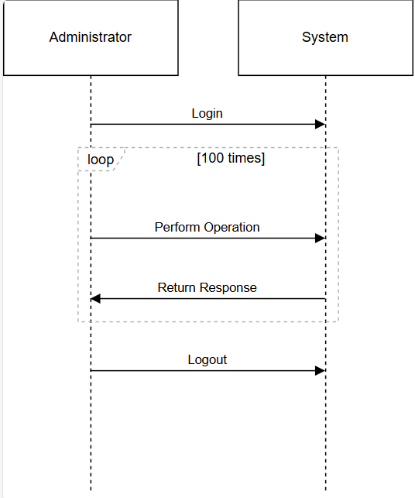

**Fig-8**

**Zain abbas**

**View reservation**

**Fig-9**

**Maintenance record**

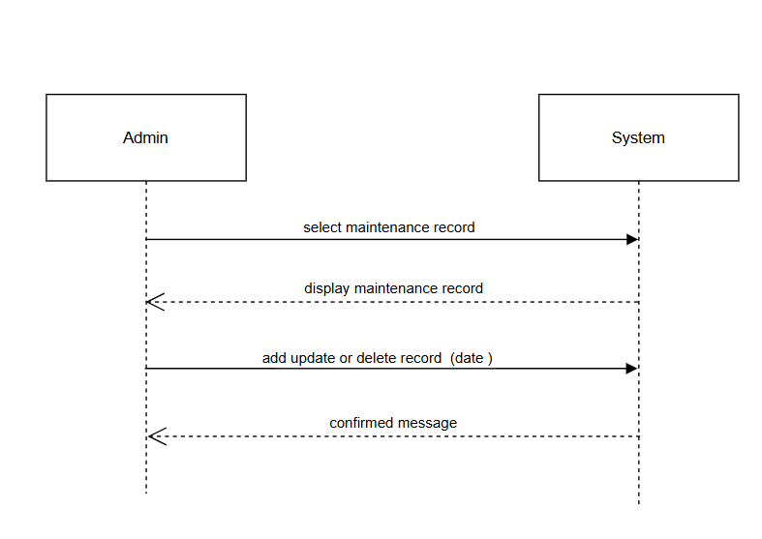

**Fig-10**

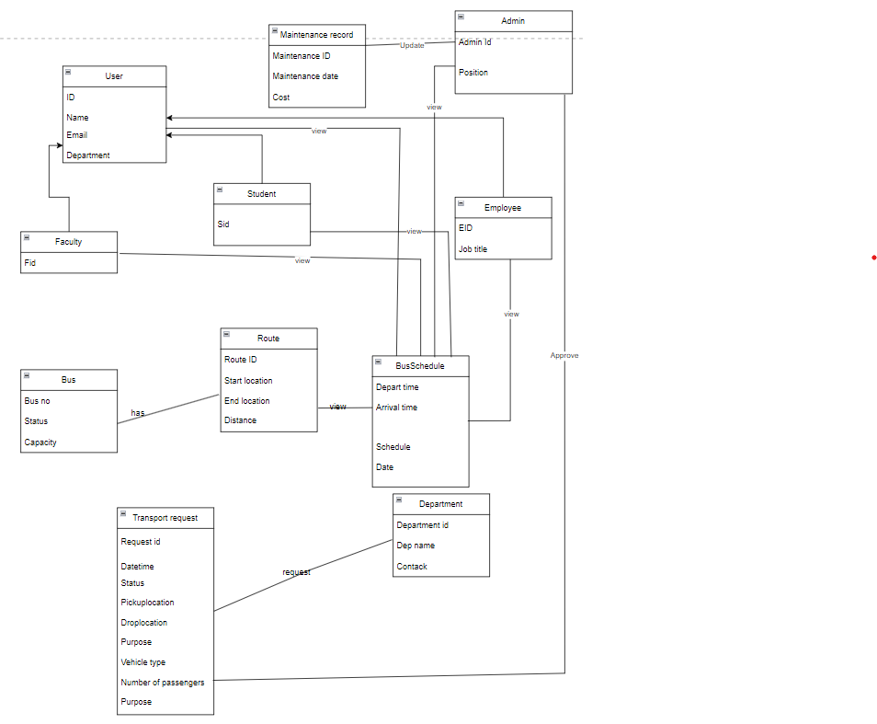**Domain model**

**Fig-8**

**Data Dictionary**

|  |  |  |  |
| --- | --- | --- | --- |
| **Attribute** | **Data Type** | **Description** | **Example Value** |
| **User_ID** | Integer | Unique identifier for each user | 101 |
| **Name** | String | Full name of the user | Talha |
| **Email** | String | User's email address | ahmed[@example.com](mailto:zain@example.com) |
| **Department** | String | User's department | Computer Science |
| **Role** | String | User role (Admin, Student, Faculty, Driver) | Student |
| **Fid** | Integer | Unique ID for faculty members | 201 |
| **Sid** | Integer | Unique ID for students | 301 |
| **EID** | Integer | Unique ID for employees | 401 |
| **Job_Title** | String | Job title of the employee | Transport Officer |
| **Admin_ID** | Integer | Unique identifier for admins | 501 |
| **Position** | String | Position held by the admin | Head of Transport |
| **Bus_No** | String | Unique bus number | QAU-123 |
| **Bus_Status** | String | Bus availability status (Operational, Under Maintenance) | Operational |
| **Capacity** | Integer (Unsigned) | Maximum passenger capacity | 40 |
| **Route_ID** | Integer | Unique identifier for each route | 12 |
| **Start_Location** | String | Bus start location | Gate No. 1 |
| **End_Location** | String | Bus end location | Hostel 5 |
| **Distance** | Float | Distance of the route in km | 5.5 |
| **Departure_Time** | Time | Scheduled departure time | 08:30 AM |
| **Bus_Schedule** | String | Description of the schedule | Morning Shift |
| **Date** | Date | Date of the scheduled trip | 2025-03-23 |
| **Maintenance_ID** | Integer | Unique maintenance record ID | 601 |
| **Maintenance_Date** | Date | Date of last maintenance | 2025-03-01 |
| **Cost** | Float | Cost of maintenance | 5000.00 |
| **Request_ID** | Integer | Unique ID for each transport request | 701 |
| **Request_DateTime** | DateTime | Date and time of request | 2025-03-23 10:00 AM |
| **Request_Status** | String | Current status of the request (Pending, Approved, Rejected) | Pending |
| **Pickup_Location** | String | Requested pickup location | Library |
| **Drop_Location** | String | Requested drop location | Hostel 3 |
| **Purpose** | String | Reason for request | University Event |
| **Vehicle_Type** | String | Type of vehicle requested | Mini Bus |
| **Number_of_Passengers** | Integer | Total number of passengers for transport | 12 |
| **Department_ID** | Integer | Unique identifier for a department | 801 |
| **Department_Name** | String | Name of the department | Transport Department |
| **Department_Contact** | String | Department contact number | +92-312-345678 |